JORDAN RETRO 4 MILITARY BLACK

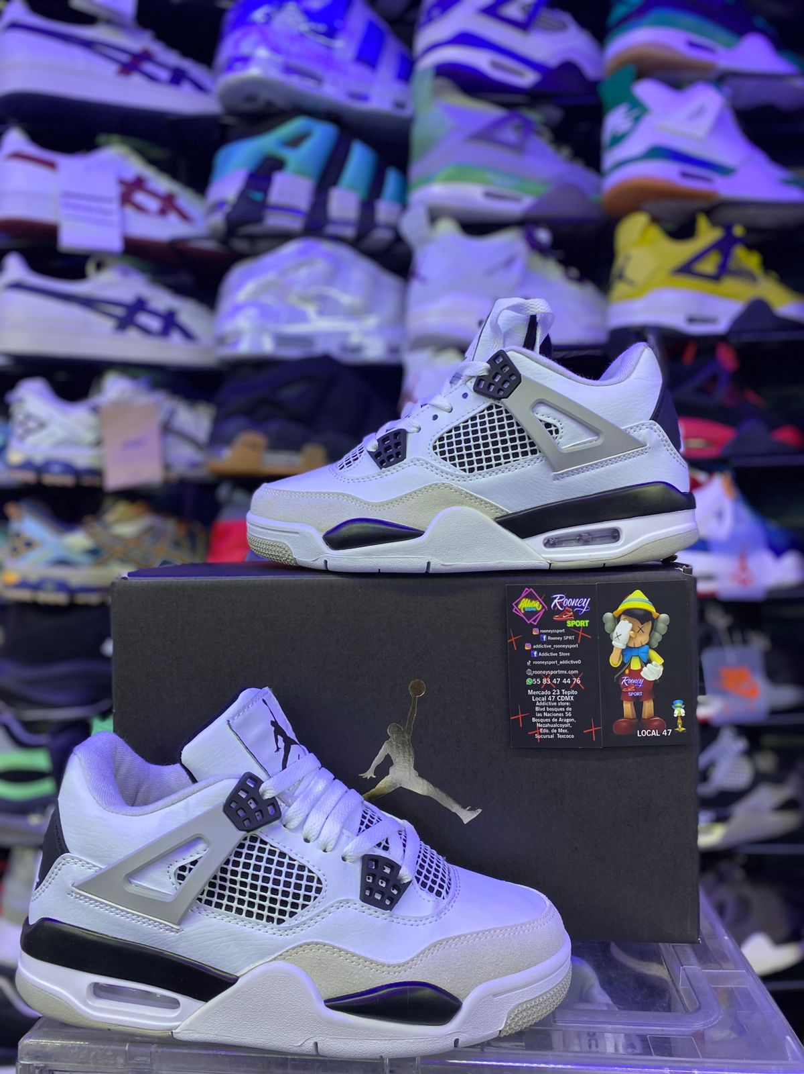

JORDAN RETRO 13 BLACK CAT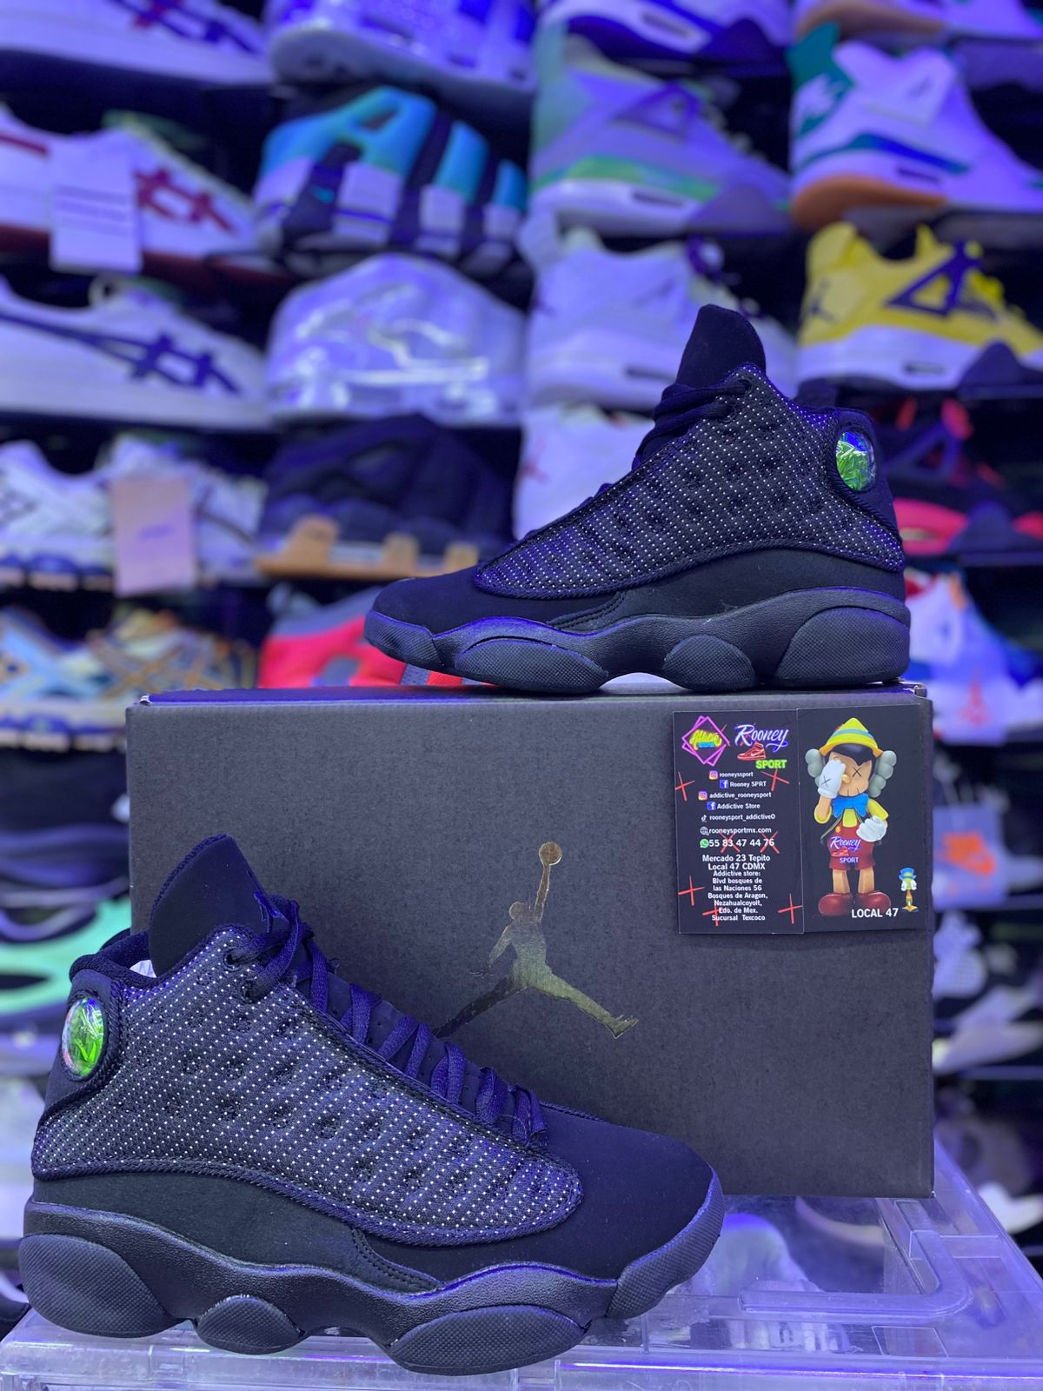

JORDAN RETRO 4 BLACK CAT

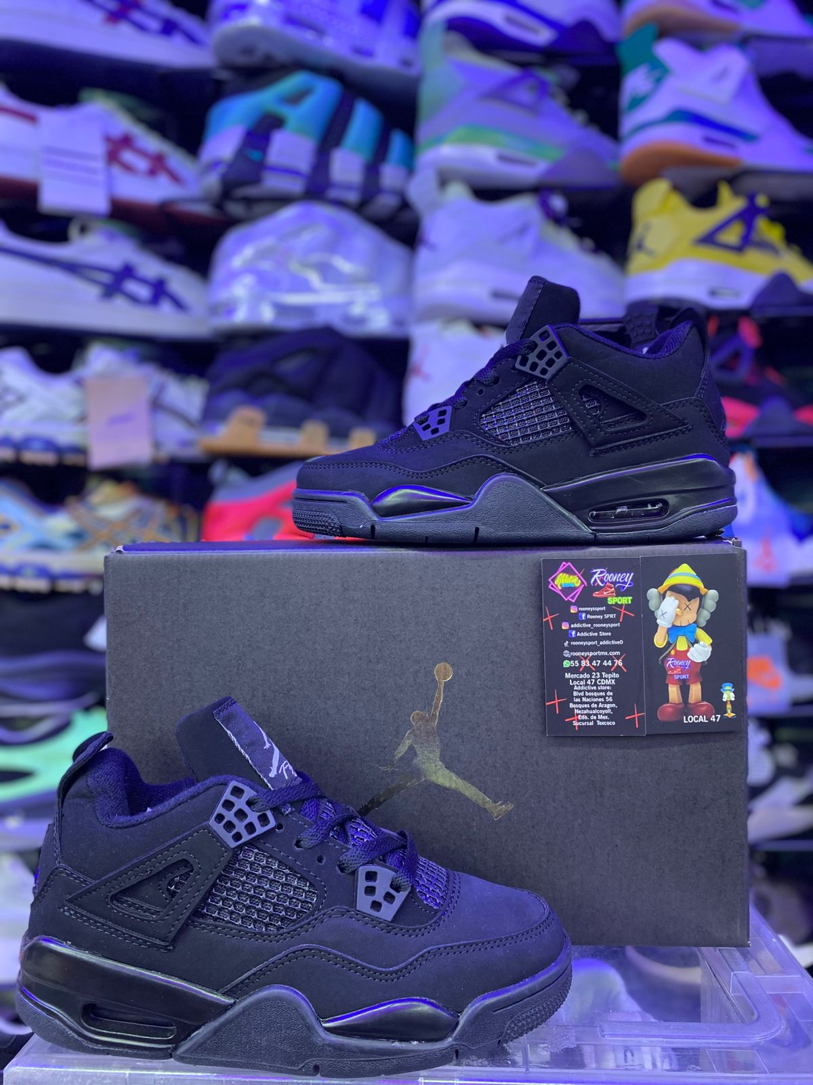

JORDAN RETRO 4 ALUMINUM

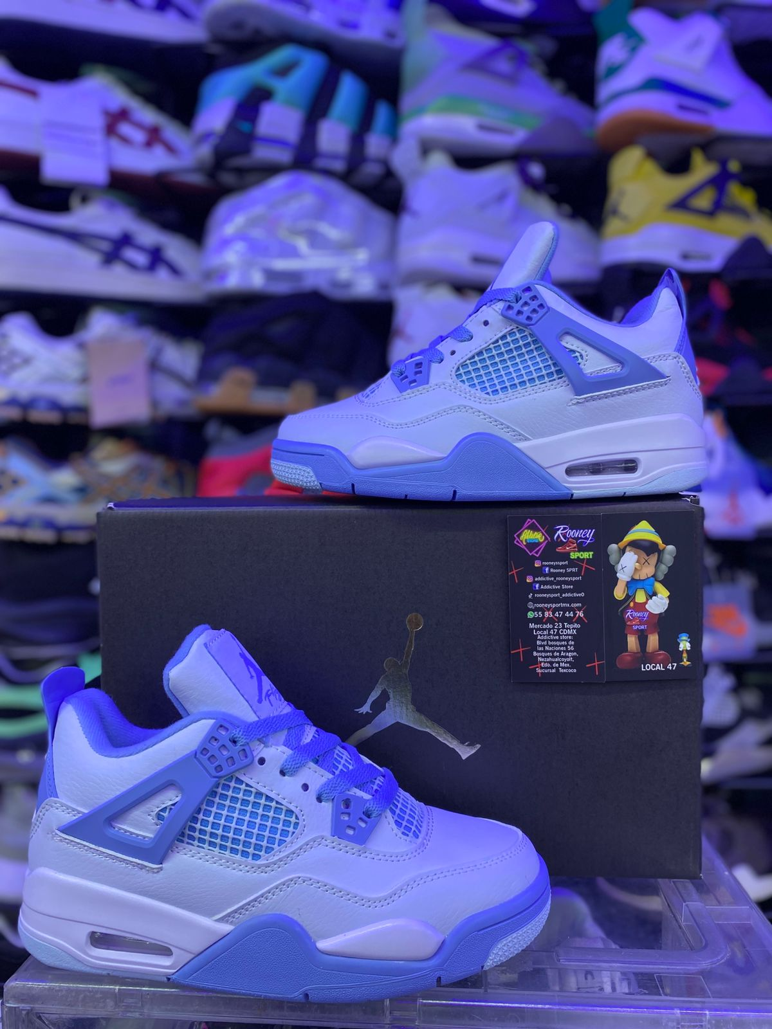

JORDAN RETRO 4 NIGEL BIKE AIR NEGRO

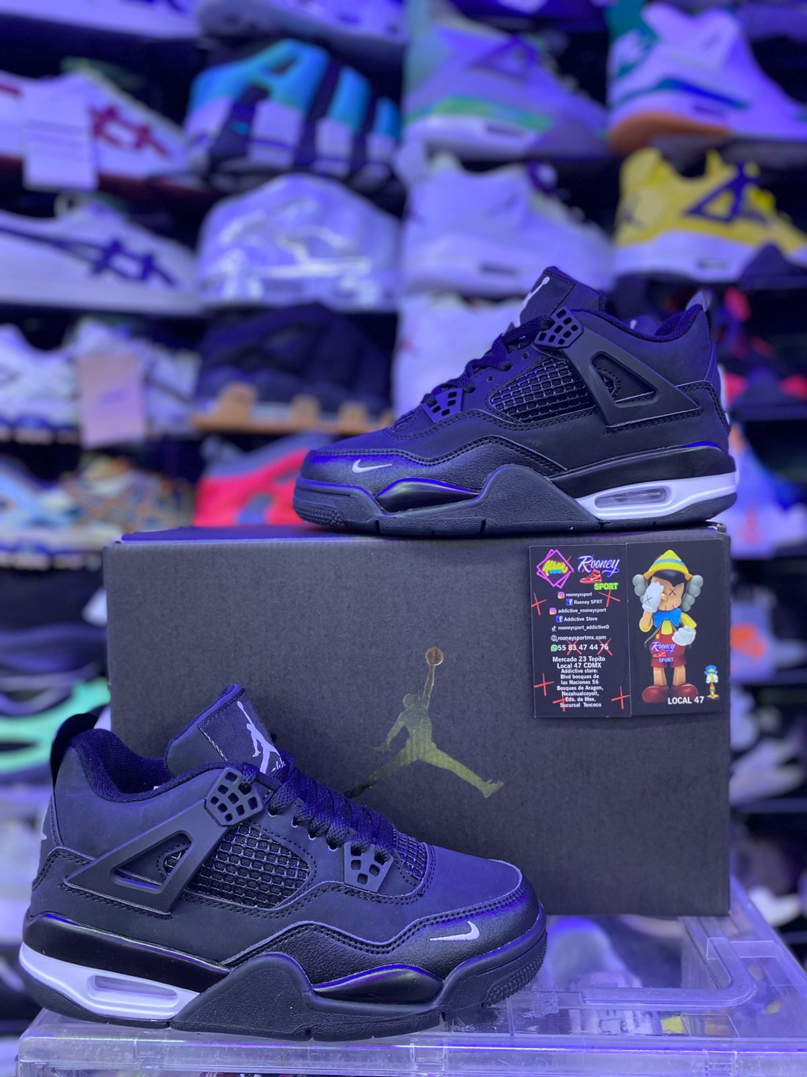

JORDAN RETRO 3 TRAVIS BEIGE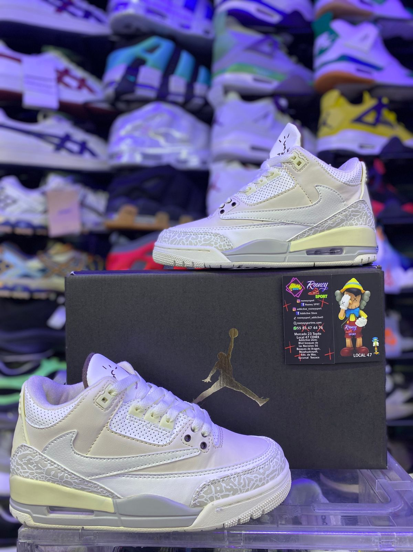

JORDAN RETRO 3 VIVID PURPLE

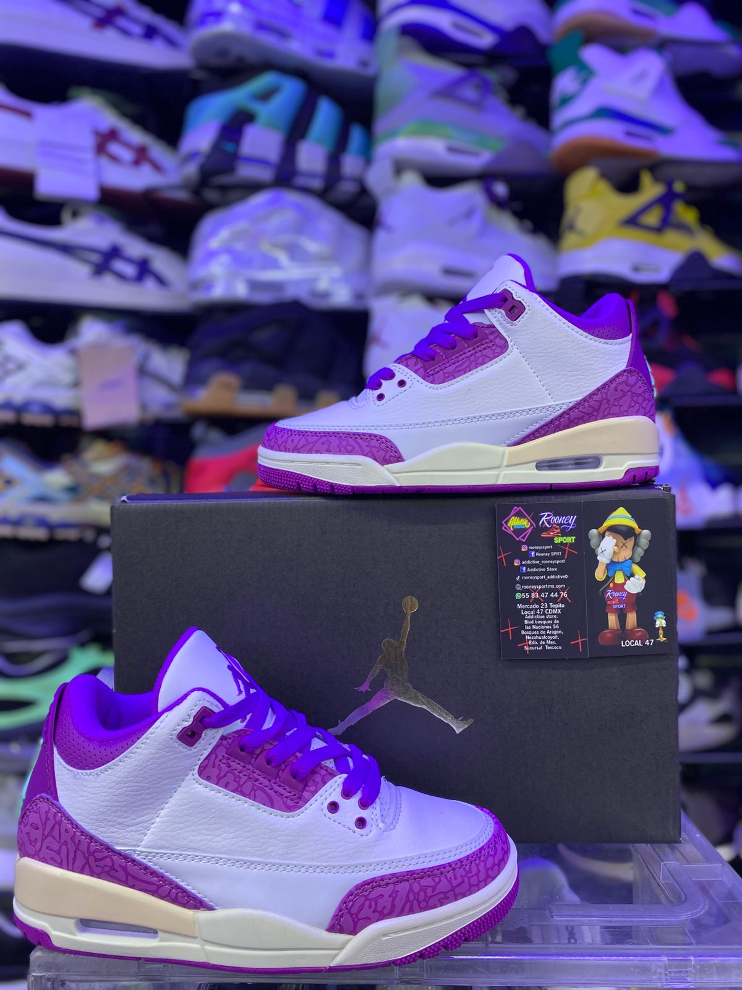

JORDAN RETRO 4 PINK OREO

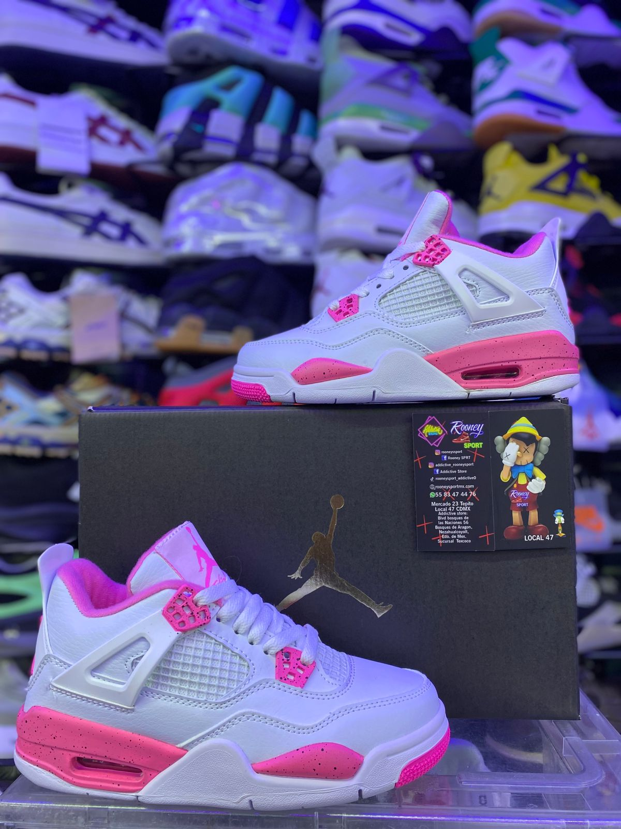

JORDAN RETRO 3 CYBER MONDAY

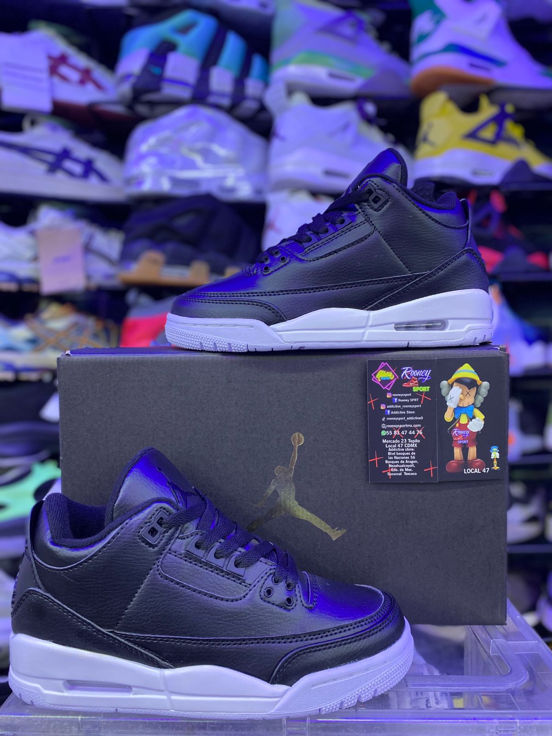

JORDAN RETRO 3 KWAS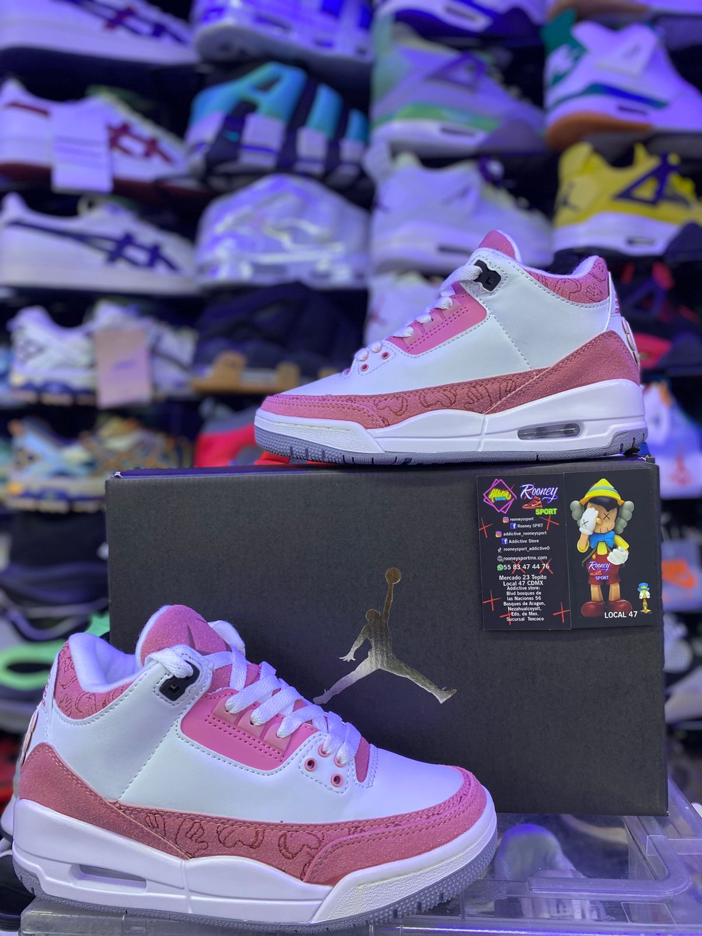

JORDAN RETRO 3 BLACK CAT

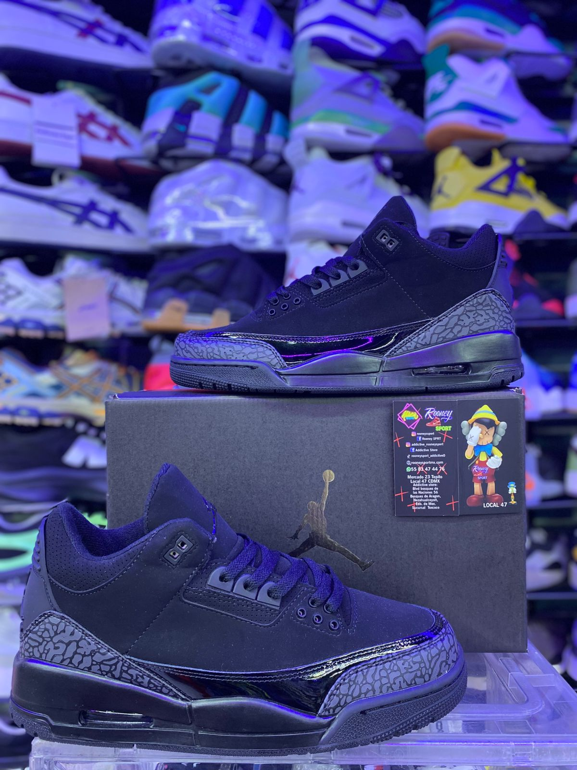

JORDAN RETRO 3 FRAGMENT DESIGN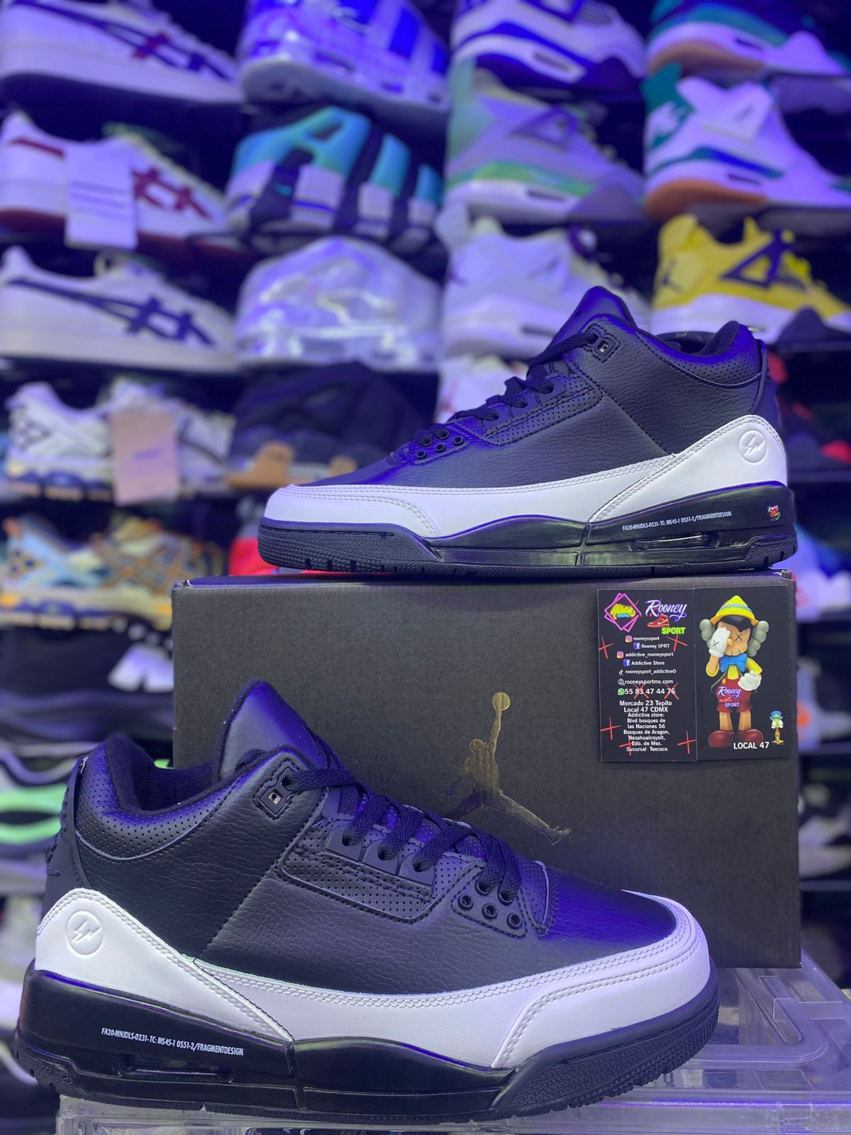

JORDAN RETRO 3 BLACK CEMENT

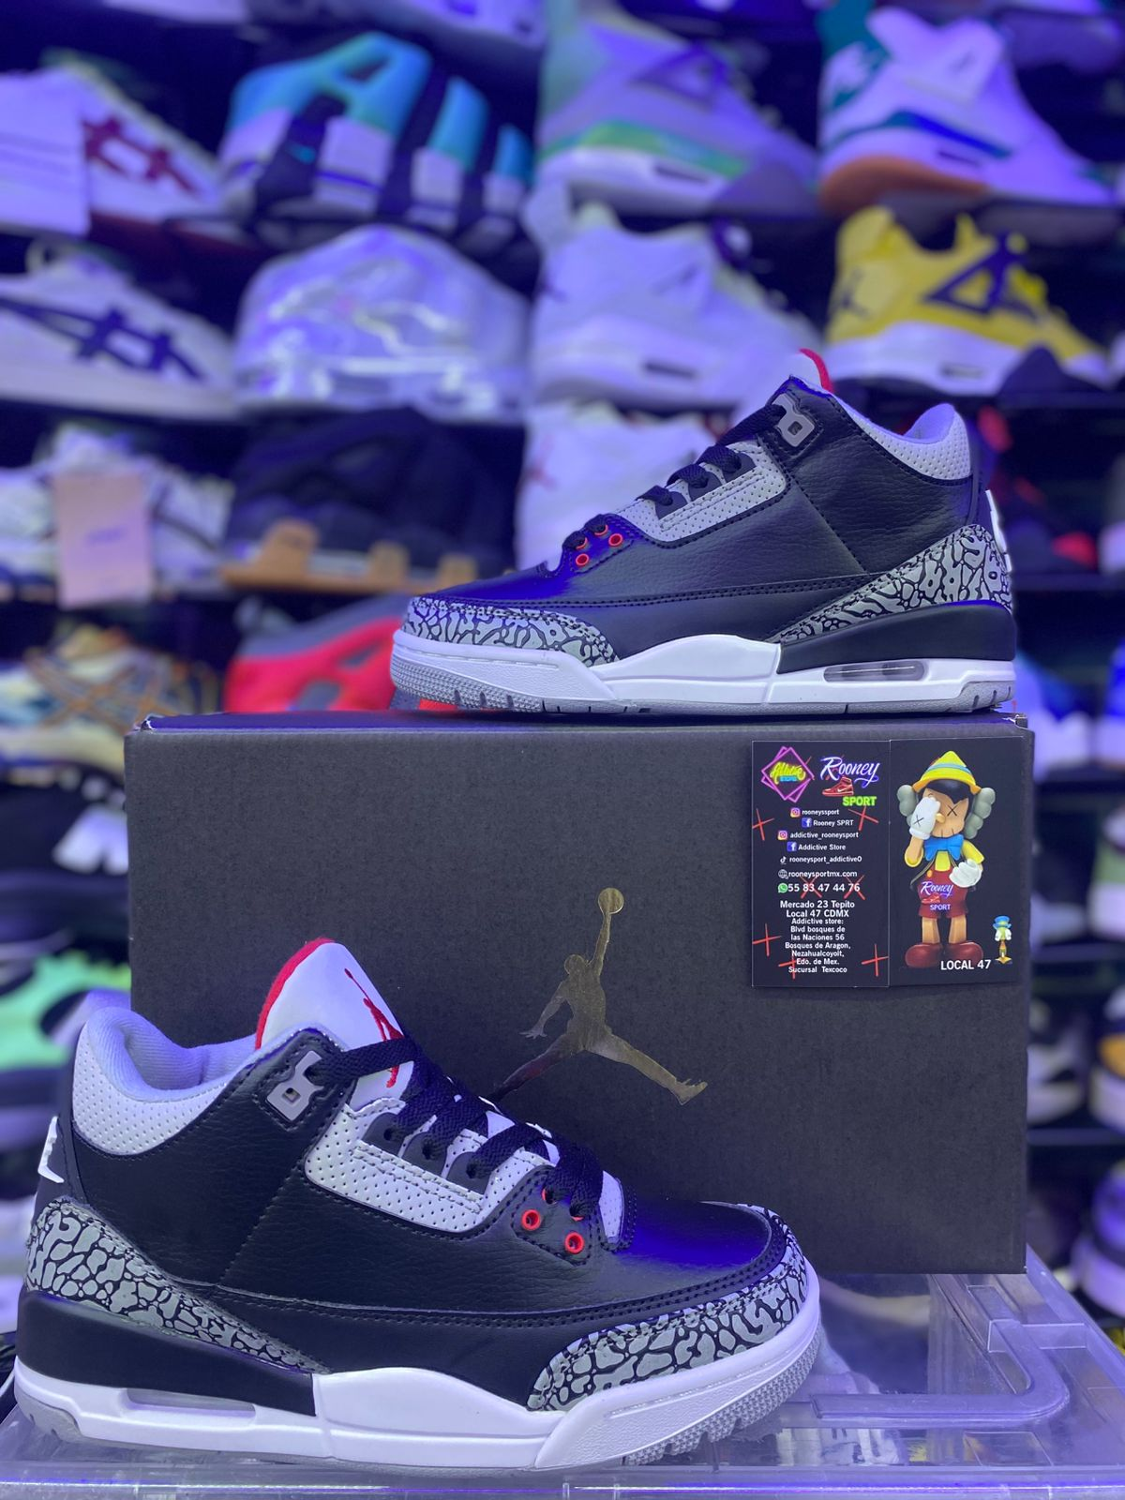

AIR JORDAN 3 X FRAGMENT

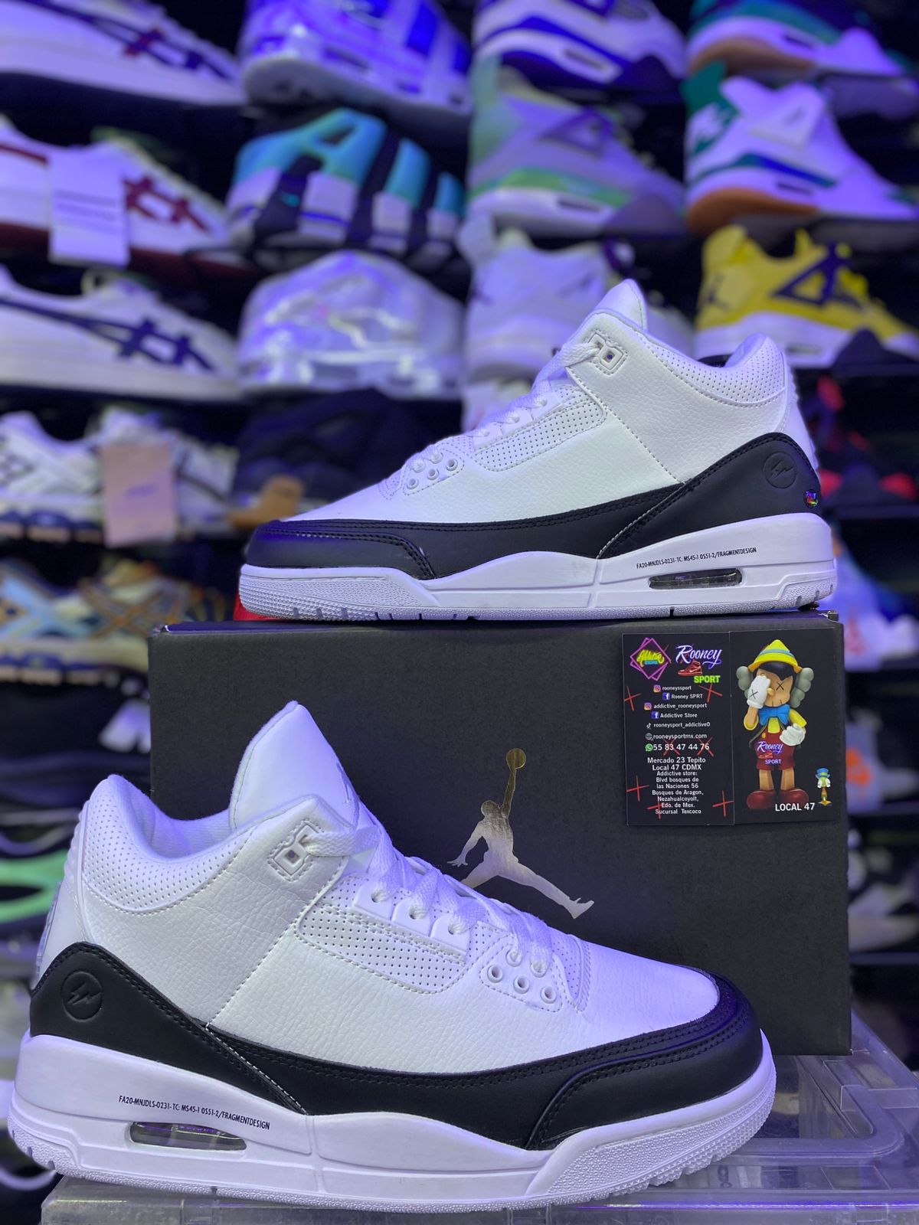

NIKE AIR 720 TORTUGA

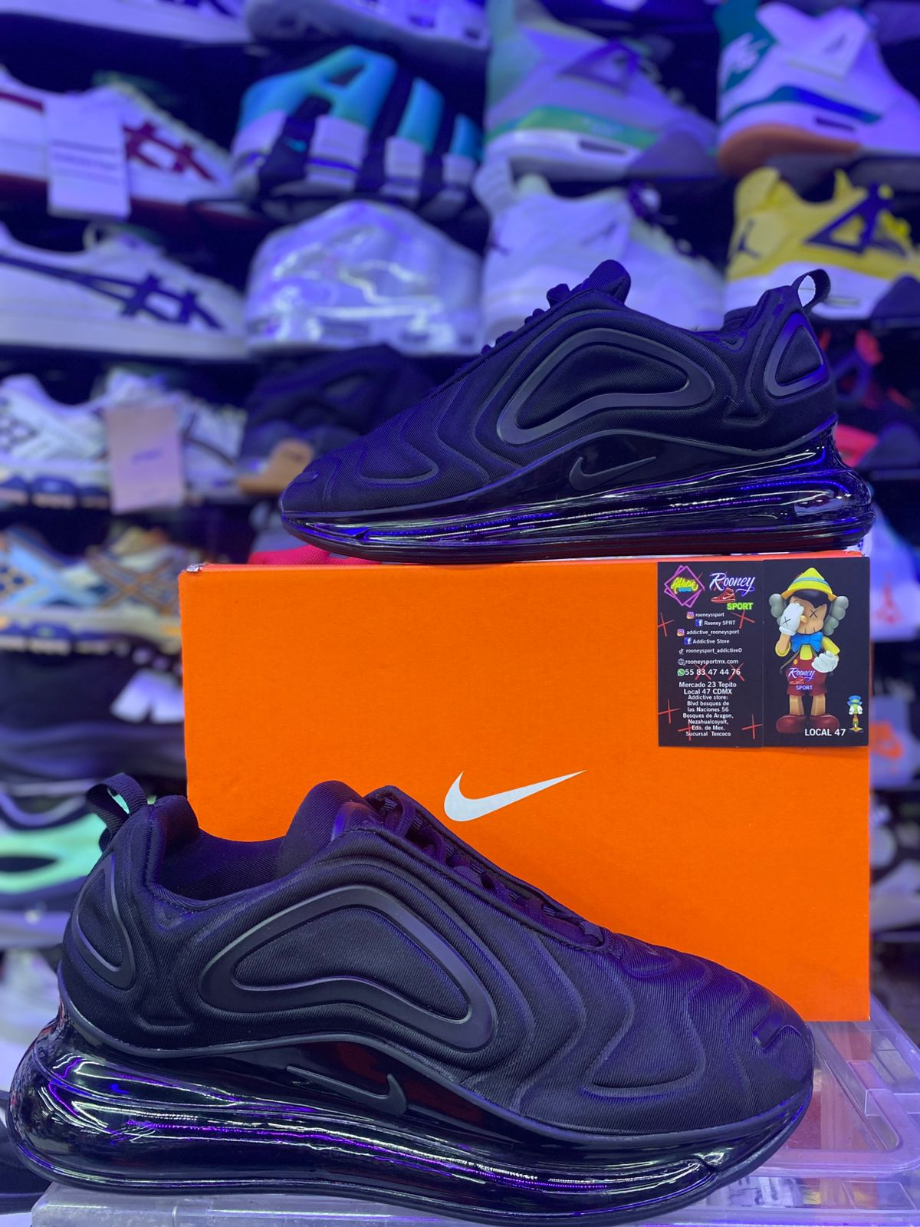

NIKE AIR 720 OREO

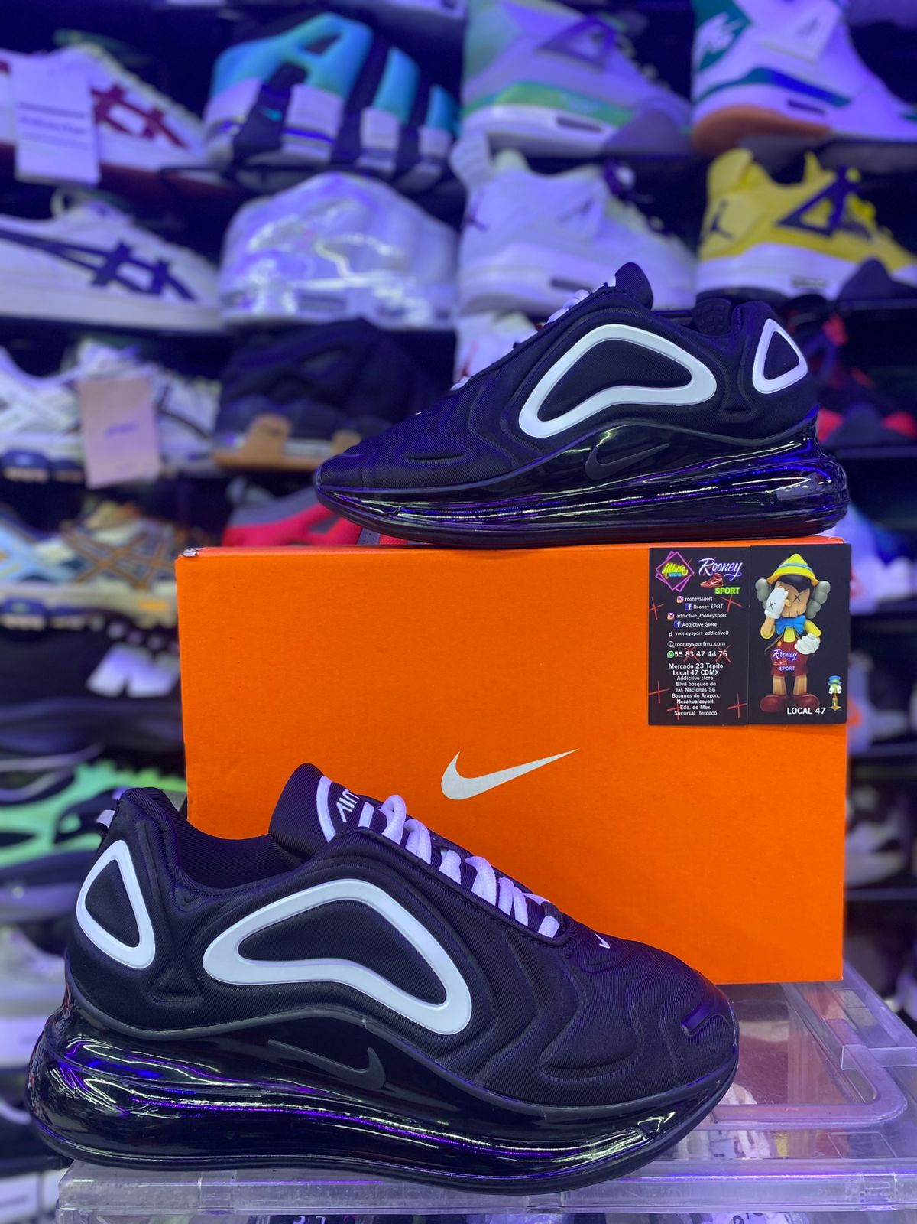

JORDAN RETRO 1 MID SPACE JAM

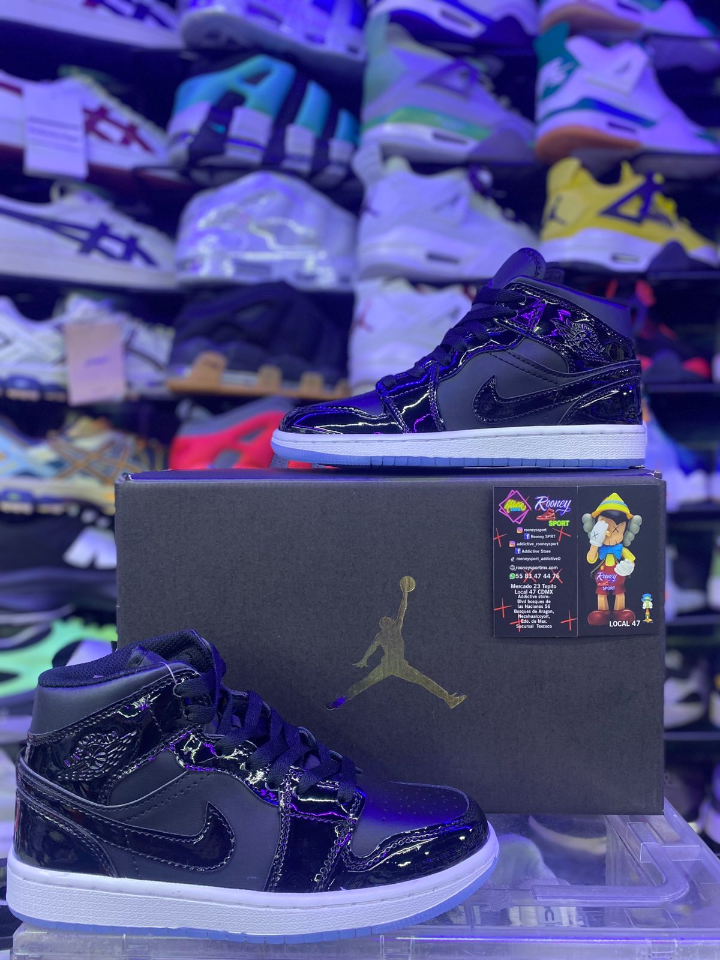

NIKE AIR ZOOM PEGASUS PREMIUM

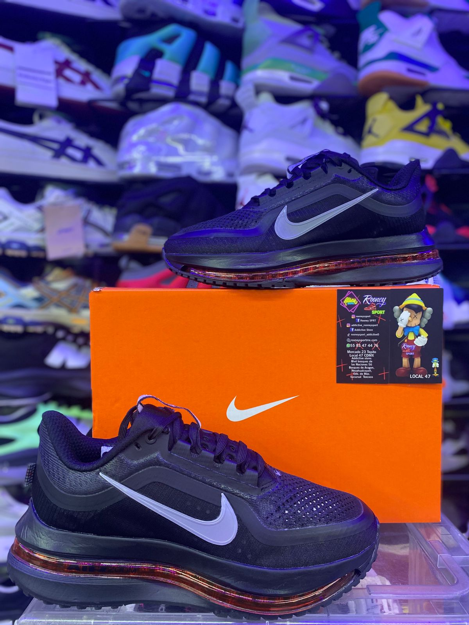

NIKE AIR ZOOM BLANCO

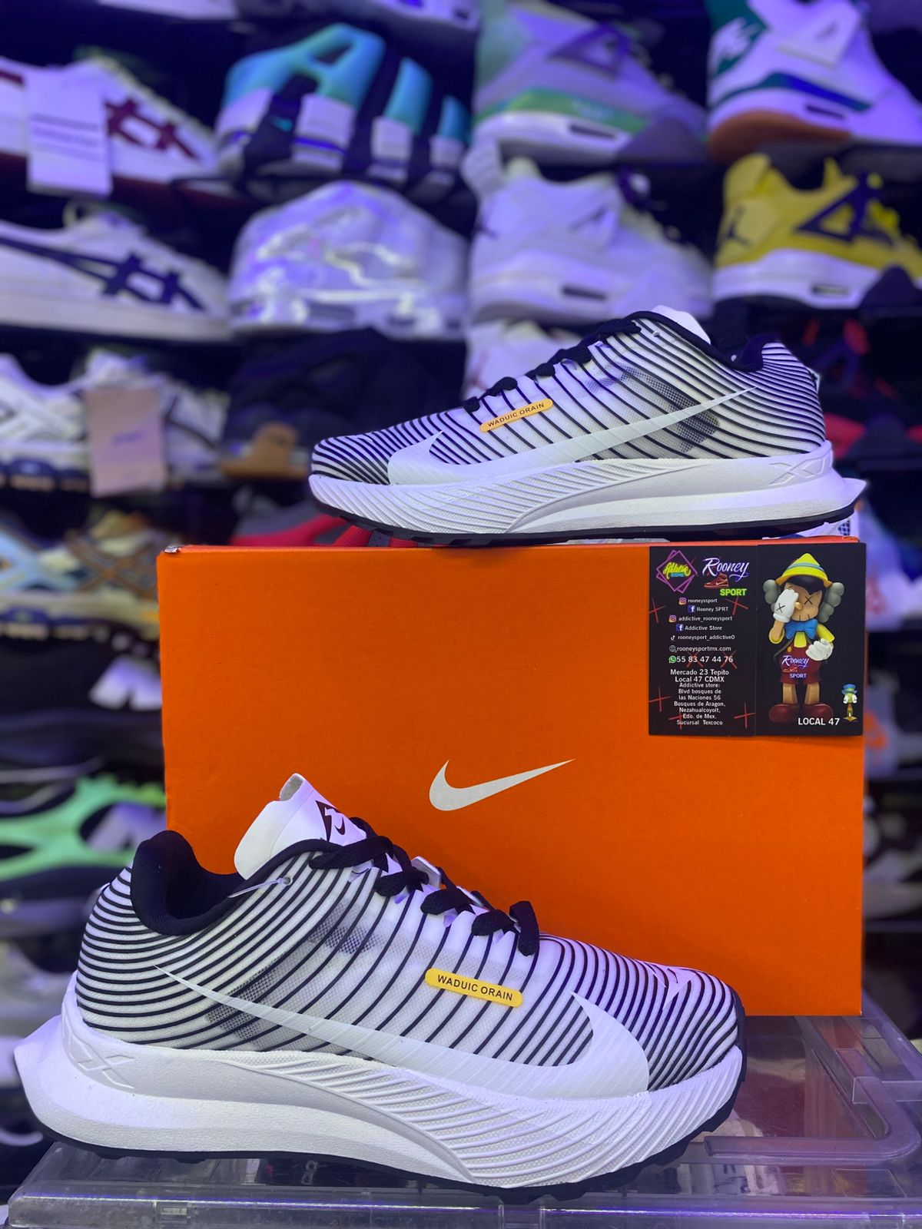

NIKE AIR ZOOM NEGRO

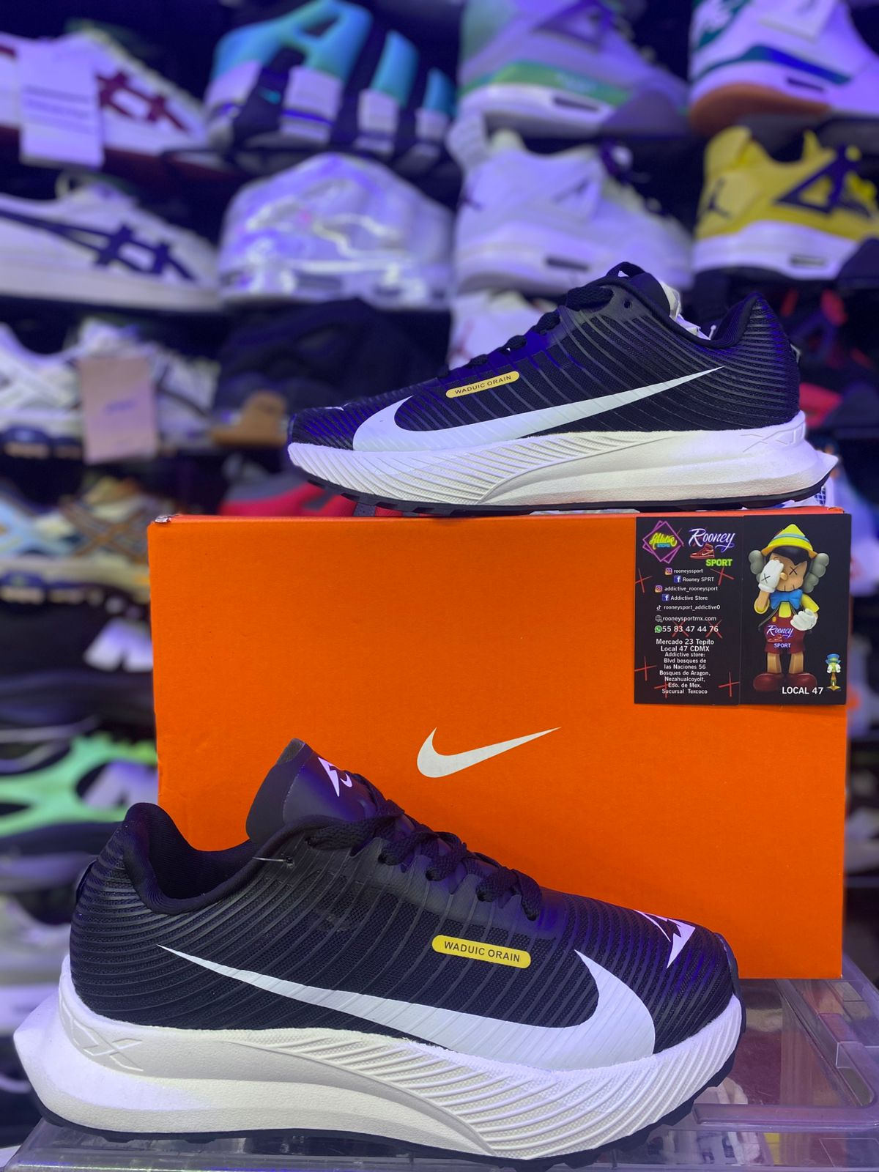

NIKE AIR ZOOM PEAGASUS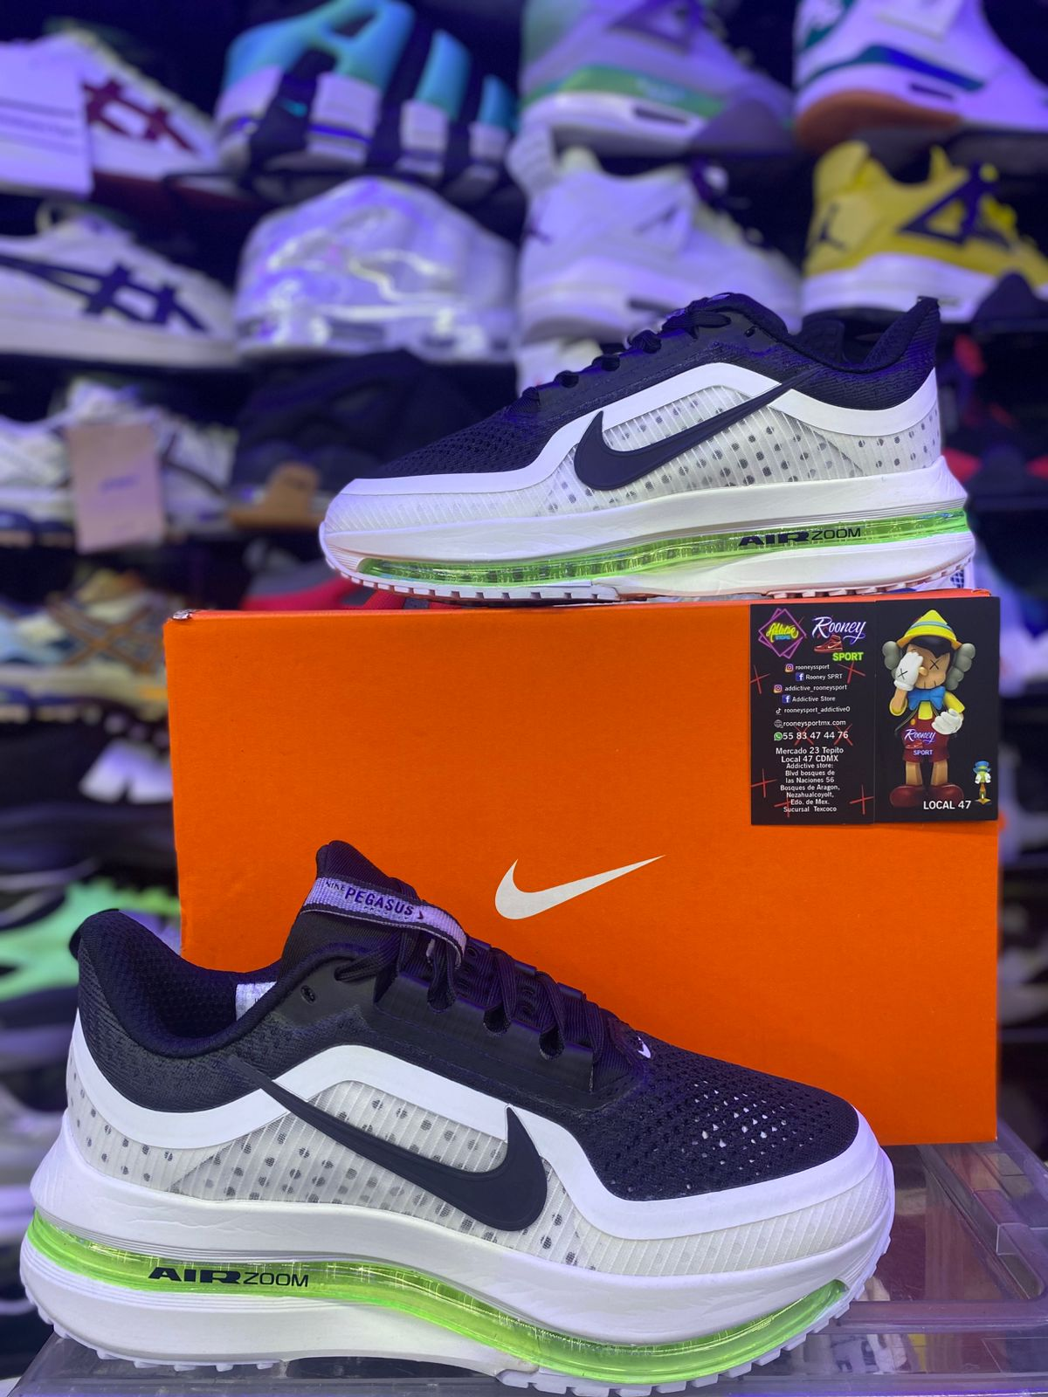

NIKE AIR ZOOM PEAGASUS PLUS BLANCK BEYOND GLACIER BLUE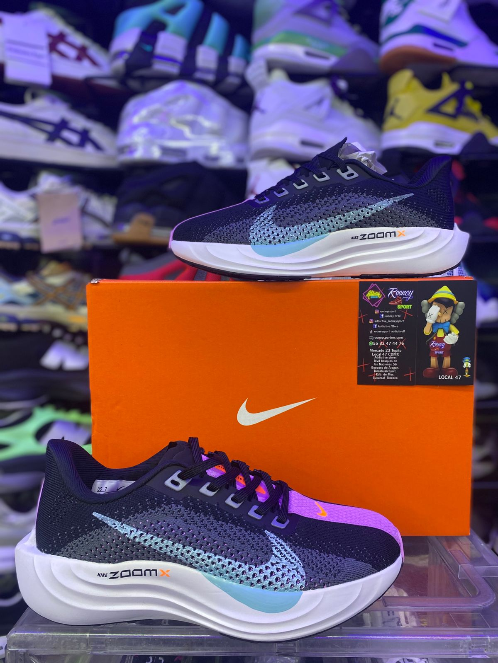

NIKE AIR ZOOM 41 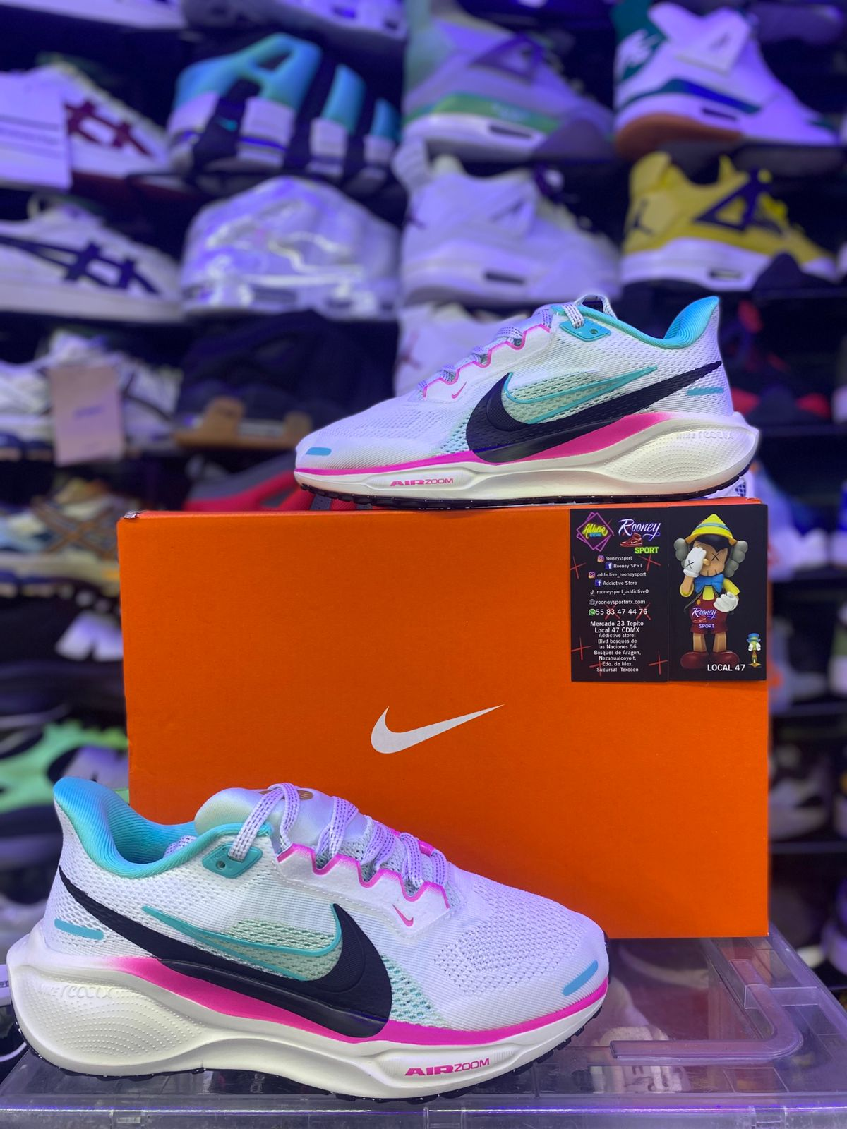

NIKE AIR ZOOM 41

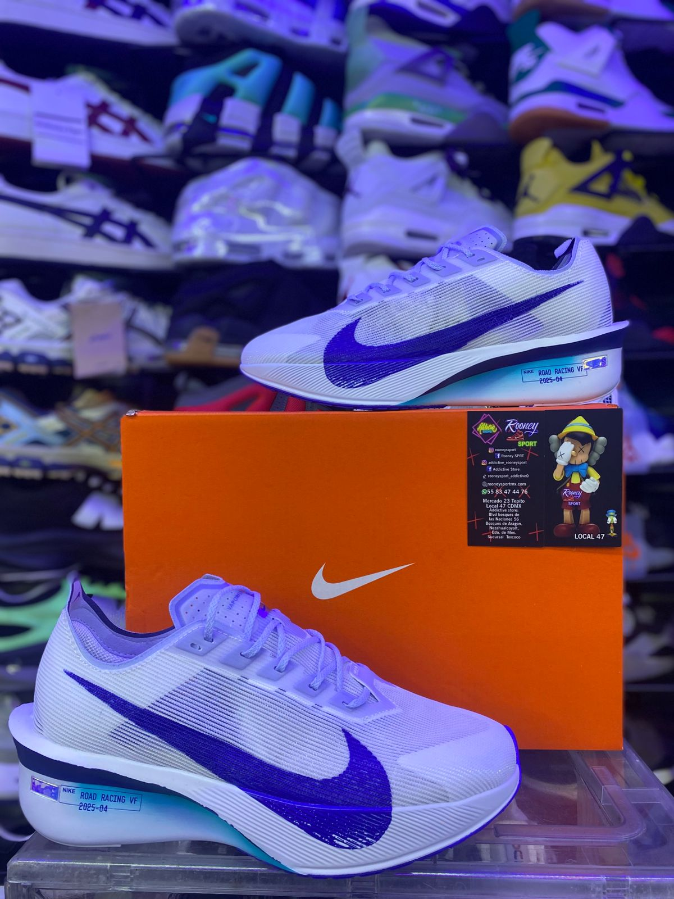

NIKE ZOOM FLY 6

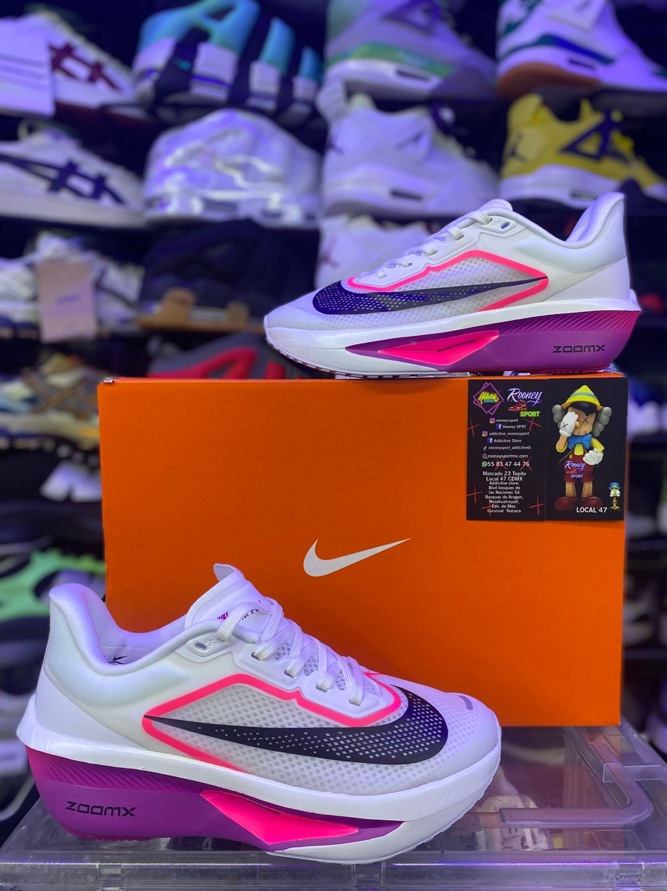

NIK ZOOMX PEGASUS PLUS

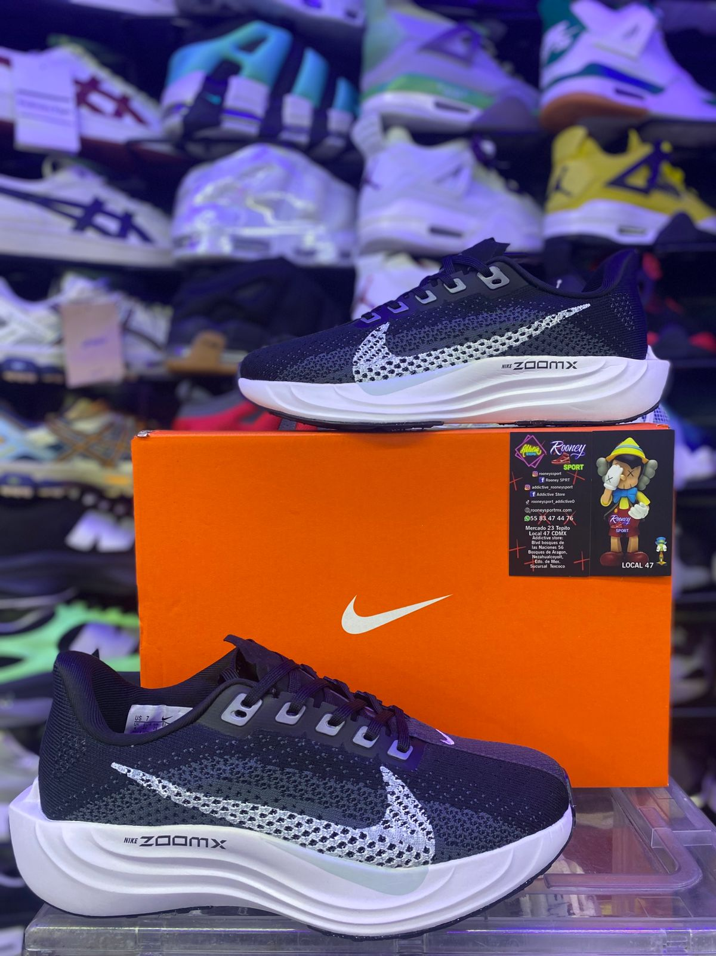

NIKE SHOX TL

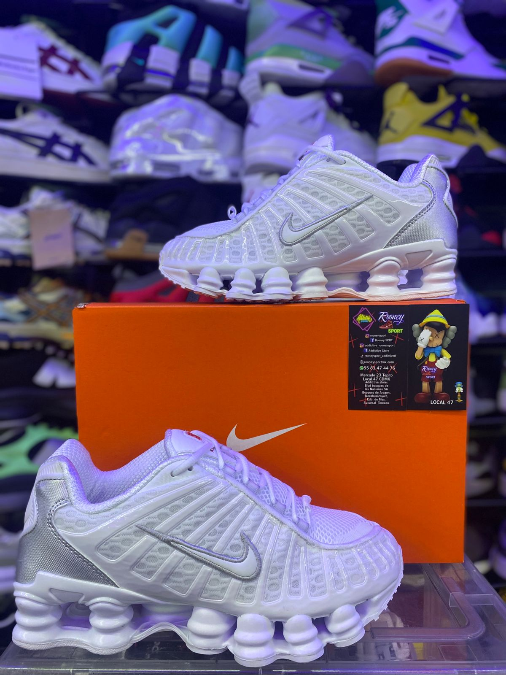

NIKE AIR MAX PLUS

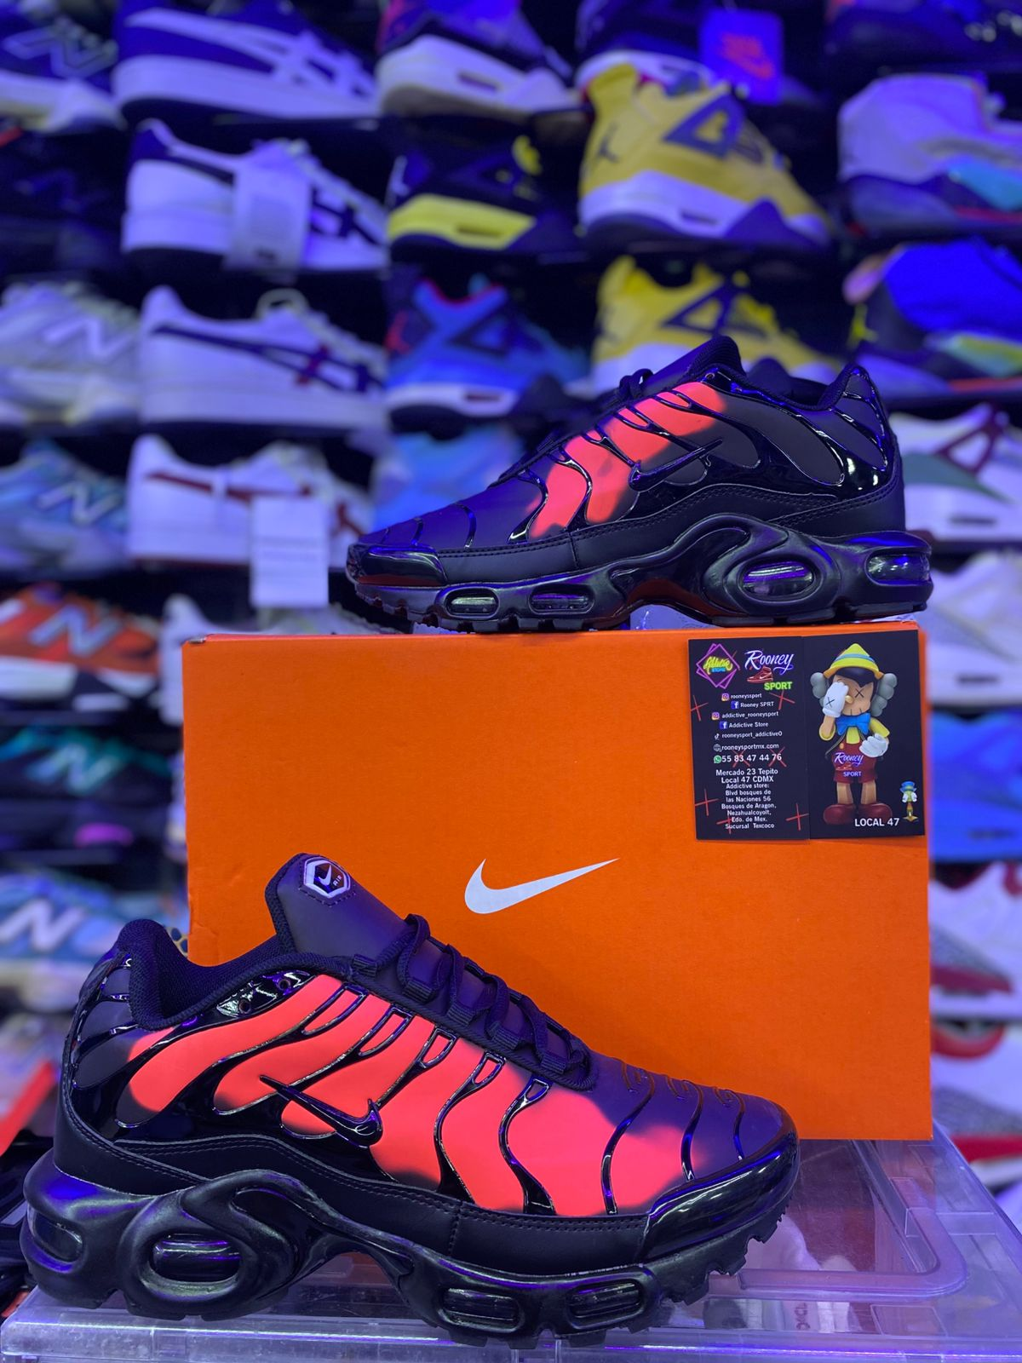

NIKE SHOX TL